
Energy and electricity | Year 6 | Unit 2
Assessment task — Exploring energy and electricity: Model response
Part A: Circuits
Plan
The components of the Steady Hand Game have been removed from the game so that you can test each one separately to identify why the game doesn’t work properly.
- You will build a circuit to test each of these components from the game:
  - Wire course
  - Wire loop, handle and connecting wire
  - Light bulb
  - Buzzer
- In the first box below, draw a labelled diagram of how you will set up your testing circuit.
- In the second box, draw a circuit diagram of the testing circuit you will build. Hint: use the following symbols in your circuit diagram.
Student responses to this question may vary, as the arrangement of the electrical components is unimportant. Responses should:
- represent an open circuit with a gap where components to be tested will be inserted
- include appropriate components connected in series, i.e. cell or series of cells, wires
- include a way of observing that the inserted component is working properly, e.g. light bulb.

 |  |  | 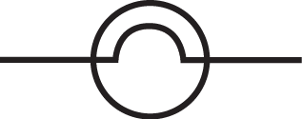
- Labelled diagram  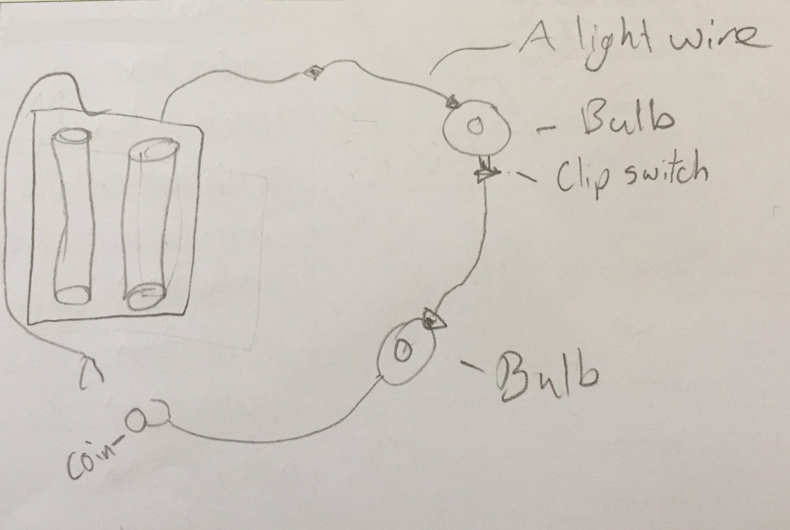 | - Circuit diagram  For example:
- Explain how you will use your testing circuit to identify which component is faulty.
I will test each component from the game by inserting it into the gap and connecting it to the wires in my testing circuit. If the component is working, then the light bulb should light up because the circuit is complete and electricity is flowing from the cell, through the bulb and back to the cell. If the bulb doesn’t light up, it tells me that the circuit is still open and electricity is not flowing around the circuit. The component must, therefore, be faulty.
Conduct
- Build your testing circuit according to your approved diagrams.
- Follow your approved method for testing each component of the Steady Hand Game, and record your observations in the table below.
Component | Observations
Wire course | The light bulb lights up.
Wire loop, handle and connecting wire | The light bulb does not light up.  The wire loop and the connecting wire in the handle are not touching.
Light bulb | The light bulb lights up.
Buzzer | The light bulb lights up.
- Analyse why the Steady Hand Game has been allowing everyone to win. Use your observations and your science knowledge.
Example response:
The game allowed everyone to win because the wire loop and the connecting wire in the handle were not touching, which meant the circuit was open and not closed. The electricity couldn’t be conducted through the wire loop handle because the metal wires were insulated by the pen casing and the tape.
- What changes can be made to the Steady Hand Game in order for it to work properly? Explain how these changes will allow the game to work properly.
Example response:
The wire loop and connecting wire need to be in contact with each other so that the only thing preventing the circuit from closing is the lack of contact between the wire loop and the wire course. When the player then touches the wire loop to the wire course it will become a closed circuit, and the buzzer and light will turn on to indicate that the player has lost the game.
Part B: Energy sources
- An island For example:
- Energy source: Wind energy
- Use a flow diagram to describe the sequence of energy transformations that need to occur for electricity generation using this energy source.
Movement energy from the wind
Electrical energy
Movement energy of blades
Movement energy of generator

- Explain the energy transformations in the sequence.
The wind energy turns the blades of the wind turbine making it rotate. A generator transforms the movement energy of the wind turbine into electrical energy through the use of electromagnetism.
- Identify advantages and disadvantages of using this source.
Advantages Disadvantages
Wind is free.  No greenhouse gases are produced when wind energy is transformed into electricity.  Can supply electricity to remote areas | Requires favourable wind conditions in order to generate electrical energy  High cost for initial set-up  May be interruptions to electricity supply because wind is unpredictable.

- Justify why this source is the best choice for the show owners. Remember to use your science knowledge and appropriate science terminology.
The location may be remote and non-renewable sources may be limited. Using abundant, clean, renewable energy from a local wind farm is the best choice. The winds in various locations around the island may be strong and wind farms can be established in large open areas so there will be a good supply of electricity for the show.
- A desert area For example:
- Energy source: Solar energy
- Use a flow diagram to describe the sequence of energy transformations that need to occur for electricity generation using this energy source.
Light energy from the sun
Electrical energy
- Explain the energy transformations in the sequence.
Light energy from the sun falls on the solar panels and is transformed by solar cells into electrical energy.
- Identify advantages and disadvantages of using this source.
Advantages Disadvantages
Relatively cheap to manufacture and maintain  Able to be replaced easily  Easy to transport and set up  It’s clean and non-polluting, so no greenhouse gases are produced when it’s transformed into electricity. | Can only generate electricity during daylight hours  Overcast weather reduces hours in which electrical energy can be generated

- Justify why this source is the best choice for the show owners. Remember to use your science knowledge and appropriate science terminology.
Sunlight is available in large quantities in desert areas, so it is the best choice. It is cheap, clean and easy to maintain. If the show owners used electricity made from coal then it would be very expensive, as the coal would have to be transported to desert communities and a power plant set up.

- Coal-mining area For example:
- Energy source: Coal
- Use a flow diagram to describe the sequence of energy transformations that need to occur for electricity generation using this energy source.
Heat energy from burning coal
Movement energy of steam
Electrical energy
Movement energy of turbine
Movement energy of generator

- Explain the energy transformations that occur for electricity generation.
The coal is burned to release heat that boils water. The boiling water forms steam. The steam pushes a turbine and makes it rotate. A generator converts the movement energy into electrical energy.
- Identify advantages and disadvantages of the source for communities.
- Example responses:
Advantages Disadvantages
Relatively cheap to produce electricity | High initial cost of power plant  Produces pollution at the site where electricity is produced  Energy must be transported a long distance to where it is used.

- Explain why this source is the best choice for the show owners.
Coal is the best choice for the show owners because it is cheap to use and it is in plentiful supply in the area. It will give the owners an uninterrupted supply of electricity for the show.
- Explain how having an understanding of how electricity can be generated would help the show owners select the most suitable energy source in each location.
Example response:
Having an understanding of ways electricity can be generated would help the show owners know how different sources of energy such as wind, solar and coal can be transformed into electrical energy. It would also help them compare the different ways of generating electricity and analyse the advantages and disadvantages.
Being able to compare different sources of electricity and analyse their advantages and disadvantages would allow the show owners to make the best choice for each location based on scientific knowledge.
Students may give an example of how having a science understanding of how electricity is generated would help the show owners make a decision.

